Visit: www.dentistsbirmingham.co.uk
L
U
T
I
O
N
S
S
M
I
L
E
S
O


ENDODONTICS

EXCELLENCE IN DENTAL CARE
with Dr Rajiv Tanday
BDS, MJDF, DipRestDent RCS(Eng), MClinDent (Endo) GDC number 114244
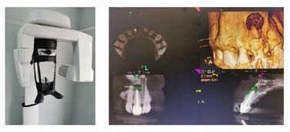
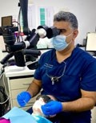

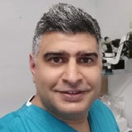
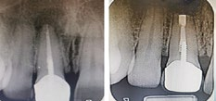
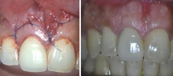
Dr Rajiv Tanday
Apical Micro Surgery
BDS, MJDF, DipRestDent RCS(Eng), MClinDent (Endo) GDC number 114244
Rajiv Qualified with Bachelor in Dental Surgery (BDS)from Guys; King’s College St. Thomas’ Dental Institute in 2007. He worked in general practice since, while obtaining post-graduate qualifications including Membership of Joint Dental Faculty (MJDF)
and a Diploma in Restorative Dentistry from the Royal College of Surgeons (London).
In 2018 he completed his master’s in clinical Dentistry in endodontics . MClinDent (Endo) and have undertaken many advanced courses including microsurgical endodontics.
He has been accepting referrals in Endodontics from dentists for the past six years and happy to receive any further referrals for root canal treatment of all levels of complexity. He is a caring and compassionate dentist who strives for clinical excellence. Your referrals are valued and respected and you can rest assured that your patients will be cared for in proficient and professional hands.
He is a member of the British Endodontic Society and very keen on postgraduate training, continuing professional development and keeping up to date with the latest development in dentistry.
Re-root canal treatment:
Instagram:@raj_tanday_endo

Making a referral to us
Rajiv is happy to accept referrals for:
- Root canal Treatment
- Re-Root canal Treatment
- Apical Surgery
- Removal of separated Instruments
If you would like to refer a patient to
us, please email all details with relevant radiographs to smilesolutionsb75@yahoo.com Alternatively they can be posted.
Our Referral form can also be down loaded and completed from our website wwwdentistsbirmingham.co.uk
Once we have received your referral, we will contact your patient within 48 hours with details of their appointment with Rajiv for a Consultation.

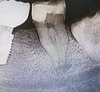
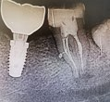

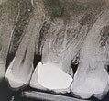
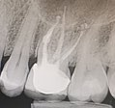
A full Treatment Plan will then be provided to your patient for consideration and a copy
can be sent to you for reference upon request.
Once treatment is completed a discharge letter will be send to referring dentist.
If you need more information about referring your patient to us at Smile Solutions for Endodontic treatment, please call us on 0121 308 8977
Or email us and our reception team will help you.
Primary root treatment with lateral canal

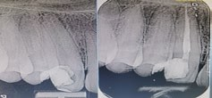

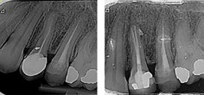

FEE GUIDE
Consultation | £52.00
CBCT | £120.00
Incisor/ canine | £450.00
Premolars | £520.00
Molars | £695.00
RE-Root Canal Treatment
Incisor/ canine | £590.00
Premolars | £620.00
Molars | £800.00
Apical Surgery | From £490.00
Vital Pulp Therapy | From 199.00
Internal tooth whitening | From 399.00
Glass Fibre Post Placement | From £190.00


Find out more
140 Mere Green Road, Sutton Coldfield B75 5DB
Call our team: 0121 308 8977
Email: smilesolutionsb75@yahoo.com
EXCELLENCE IN
DENTAL CARE
Visit: www.dentistsbirmingham.co.uk
L
U
T
I
O
N
S
S
M
I
L
E
S
O

